Reverse-Engineered Business Requirements
TrackAllLoanMaintenanceLegacy
────────────────────────────
Loan Maintenance Modernization Document Set

Table of Contents
1. Introduction
1.1 Purpose
1.2 Scope
1.3 How to read this document
1.4 Definitions and grounding labels
2. Business Context
2.1 Where this subdomain fits
2.2 Subdomain Registry
2.3 This slice vs the full subdomain scope
2.4 System Context — Current State
3. Functional Requirements by Subdomain
Subdomain: Loan Maintenance
Feature: Loan Search
Feature: Add Loan
Feature: Modify Loan
Subdomain: RatingService
Feature: Premium Quote Orchestration
Subdomain: EdiNotificationService
Feature: 14E Dispatch and Audit
4. Business Rules Register
Loan Maintenance — Loan Search Input Validation
Loan Maintenance — Premium Rating
Loan Maintenance — EDI Notification
Loan Maintenance — Audit Trail
Loan Maintenance — Add Loan Validation
Loan Maintenance — Modify Loan Validation
Loan Maintenance — Integration Gateway
5. Field Reference
5.1 Key fields
5.2 Validation precedence
6. Open Items and Ambiguities
7. Non-Functional Considerations
8. Traceability Summary
9. Appendix

Document Governance Note
Grounding labels covered in this publication set: [SG], [SG-influenced], [inferred], [placeholder]. Review Priority badges are styled as Priority or Standard where rule-review columns appear.

Reverse-Engineered Business Requirements

1. Introduction

1.1 Purpose
This document presents business-facing requirements extracted from governed static analysis of the legacy source for the Loan Maintenance slice.

1.2 Scope
This run covers Loan Maintenance: Loan Search, Add Loan, Modify Loan, premium quote orchestration, and 14E EDI dispatch. It does not cover Client Management capabilities.

1.3 How to read this document
- Section 3 contains functional requirements grouped by subdomain and feature.
- Section 4 contains Plain-English business rules for stakeholder validation.
- Section 6 lists unresolved items that need SME input.
- Section 8 provides one-row-per-rule traceability into modernization specs.

1.4 Definitions and grounding labels
- source-grounded: extracted directly from governed artifacts.
- code-grounded: directly evidenced in source code references listed in rule cards.
- inferred: reasoned estimate that requires validation.
- placeholder: synthetic/sample-only values; none are treated as confirmed requirements.

2. Business Context

2.1 Where this subdomain fits
TrackAll Loan Maintenance is the operational slice where users search, add, and modify mortgage-loan insurance records and trigger quote and notification workflows.

2.2 Subdomain Registry
Subdomain | Identified Features | Source Dialogs | Key Integration Points
Loan Maintenance | Loan Search, Add Loan, Modify Loan | CLoanSearchDlg, CLoanAddDlg, CLoanModifyDlg | LOAN_SEARCH/TKA900, ADD_LOAN/TKA901, MODIFY_LOAN/TKA902, LSS_LOAN_T
RatingService | Quote required gate, carrier eligibility, KY ISO pre-call, rating request | CLoanSearchDlg (ProcessLoanResult), CRataBaseServiceAdapter | KY_ISO_QUERY/AIP930, RataBase external service, LSS_CYCLE_STEP_T
EdiNotificationService | EDI eligibility, format selection, audit payload, dispatch | CLoanSearchDlg (ProcessLoanResult), CEDINotificationWriter | 14E_NOTIFY/TKA920, LSS_LOAN_T, lender target list
TandemGatewayClient | Mnemonic routing resolution and dispatch boundary | CTMELibAdapter | LSS001T routing table, fgatetcp/TLS transport

2.3 This slice vs the full subdomain scope
This slice is limited to Loan Maintenance transaction paths visible in the current source pack. Additional dialogs from the full TrackAll estate are outside this publication set.

2.4 System Context — Current State
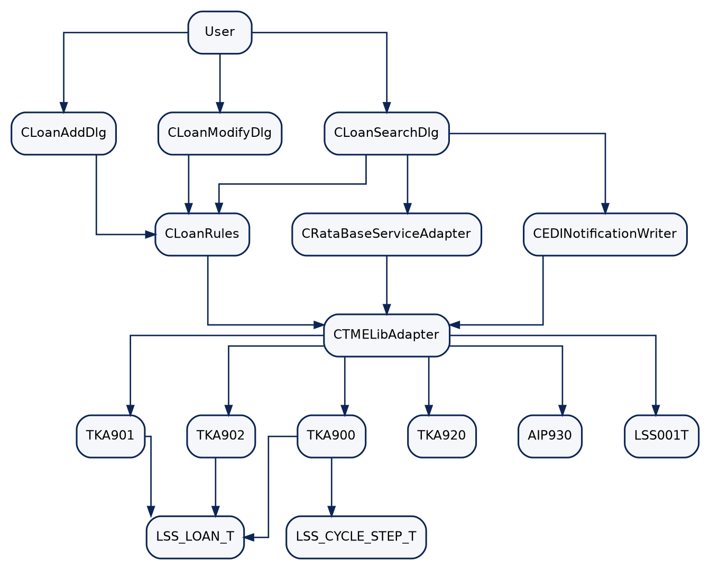
Mermaid diagram rendered from source (1)

3. Functional Requirements by Subdomain

Subdomain: Loan Maintenance

Feature: Loan Search
Feature description: Search retrieves loan data and cycle configuration using provided criteria.
ID | Requirement | Business Rule Ref | Grounding | Review Priority
FR-L-001 | System shall accept search by loan number and borrower name, and allow property address as a standalone criterion. | R-L-001, R-L-003 | code-grounded | Standard
FR-L-002 | System shall reject search submissions with no criteria. | R-L-001 | code-grounded | Standard
FR-L-003 | System shall enforce 10-digit numeric loan-number format when loan number is provided. | R-L-002 | code-grounded | Standard

Feature: Add Loan
Feature description: Add flow validates required fields and persists a new loan record.
ID | Requirement | Business Rule Ref | Grounding | Review Priority
FR-L-009 | System shall validate required fields and business constraints before Add Loan dispatch. | R-L-013 to R-L-019 | code-grounded | Standard

Feature: Modify Loan
Feature description: Modify flow enforces immutable key and controlled update constraints.
ID | Requirement | Business Rule Ref | Grounding | Review Priority
FR-L-010 | System shall validate modify constraints including key immutability, status transitions, UPB direction, and address non-clear. | R-L-021 to R-L-024 | code-grounded | Standard
FR-L-011 | System shall enforce registered mnemonic routing before backend dispatch. | R-L-025 | code-grounded | Standard

Subdomain: RatingService

Feature: Premium Quote Orchestration
Feature description: Quote path is conditionally required by cycle configuration and enforces rating prerequisites.
ID | Requirement | Business Rule Ref | Grounding | Review Priority
FR-L-004 | System shall require quote retrieval when cycle configuration indicates quote required. | R-L-004 | code-grounded | Standard
FR-L-005 | System shall permit rating only for approved states and require KY ISO pre-call for Kentucky loans. | R-L-005, R-L-006 | code-grounded | Standard

Subdomain: EdiNotificationService

Feature: 14E Dispatch and Audit
Feature description: EDI path evaluates eligibility, selects format, and emits audit-enriched dispatch payloads.
ID | Requirement | Business Rule Ref | Grounding | Review Priority
FR-L-006 | System shall evaluate EDI eligibility and suppress dispatch when eligibility fails. | R-L-008, R-L-009, R-L-010 | code-grounded | Standard
FR-L-007 | System shall select BK or SSP 14E format by FCI prefix. | R-L-011 | code-grounded | Standard
FR-L-008 | System shall include audit payload data for each 14E dispatch event. | R-L-012 | code-grounded | Standard

4. Business Rules Register
Review Priority flags which rules the business should read closely. Priority rules include inferred, sample-derived, or ambiguous content and warrant careful validation. Standard rules trace directly to legacy code and can be skimmed.

Loan Maintenance — Loan Search Input Validation
Rule ID | Rule Statement | Rule Type | Grounding | Review Priority
R-L-001 | Before submitting a loan search, the user must provide at least a loan number or a borrower name; property address may alternatively be used as the sole criterion. | validation | code-grounded | Standard
R-L-002 | When a loan number is entered, it must be exactly ten digits and numeric only. | validation | code-grounded | Standard
R-L-003 | Property address can be used alone as a valid search criterion. | validation | code-grounded | Standard

Loan Maintenance — Premium Rating
Rule ID | Rule Statement | Rule Type | Grounding | Review Priority
R-L-004 | If quote-required is Y, a quote must be obtained before result completion. | state transition | code-grounded | Standard
R-L-005 | Rating is only allowed for approved states. | validation | code-grounded | Standard
R-L-006 | Kentucky loans require ISO advisory lookup before rating call. | integration rule | code-grounded | Standard
R-L-007 | Property value must be greater than zero for quote generation. | validation | code-grounded | Standard

Loan Maintenance — EDI Notification
Rule ID | Rule Statement | Rule Type | Grounding | Review Priority
R-L-008 | 14E dispatch requires EDI enrollment flag Y. | validation | code-grounded | Standard
R-L-009 | Instant Issue cycle suppresses 14E dispatch. | validation | code-grounded | Standard
R-L-010 | Form ID must be registered in lender target list. | validation | code-grounded | Standard
R-L-011 | EDI format is selected by FCI prefix (BK fixed-width, otherwise SSP delimited). | integration rule | code-grounded | Standard

Loan Maintenance — Audit Trail
Rule ID | Rule Statement | Rule Type | Grounding | Review Priority
R-L-012 | Audit record payload must accompany each 14E dispatch event. | audit rule | code-grounded | Standard

Loan Maintenance — Add Loan Validation
Rule ID | Rule Statement | Rule Type | Grounding | Review Priority
R-L-013 | Add Loan requires loan number and borrower name. | required field | code-grounded | Standard
R-L-014 | Add Loan loan number must be exactly 10 numeric digits. | validation | code-grounded | Standard
R-L-015 | Add Loan property value must be greater than zero. | validation | code-grounded | Standard
R-L-016 | Add Loan requires property address. | required field | code-grounded | Standard
R-L-017 | New loans must start with status ACTIVE. | state transition | code-grounded | Standard
R-L-018 | Add Loan UPB must be greater than zero. | validation | code-grounded | Standard
R-L-019 | Property type must be RESIDENTIAL or COMMERCIAL. | validation | code-grounded | Standard
R-L-020 | Loan number must be unique. | persistence rule | code-grounded | Standard

Loan Maintenance — Modify Loan Validation
Rule ID | Rule Statement | Rule Type | Grounding | Review Priority
R-L-021 | Loan number cannot change after creation. | validation | code-grounded | Standard
R-L-022 | Allowed status transitions: ACTIVE->DELINQUENT->CLOSED. | state transition | code-grounded | Standard
R-L-023 | UPB cannot increase during modification. | validation | code-grounded | Standard
R-L-024 | Property address cannot be cleared during modification. | validation | code-grounded | Standard

Loan Maintenance — Integration Gateway
Rule ID | Rule Statement | Rule Type | Grounding | Review Priority
R-L-025 | TME mnemonic must be registered before message dispatch. | integration rule | code-grounded | Standard

5. Field Reference

5.1 Key fields
Field | Business Meaning | Constraints | Audit Behavior
Loan Number | Primary loan identifier | 10-digit numeric; immutable after add | Included in EDI audit payload
Borrower Name | Customer identity on loan | Required on add | Included in payload context
Property Address | Collateral location | Required on add; cannot clear on modify | Included in transaction payload
Property State | Carrier/rating jurisdiction | Must be approved for rating; KY pre-call path | Included in rating context
QuoteReqd | Cycle-level quote gate | Y requires quote | Determines quote branch execution
CycleType | Processing cycle classification | INSTANT_ISSUE suppresses 14E | Used in EDI eligibility trail
EdiFlag | EDI enrollment toggle | Must be Y for dispatch | Included in audit message
FormId | Lender form identifier | Must exist in lender target list | Included in dispatch metadata
FciCode | Servicer code | BK prefix selects fixed-width format | Included in format decision trail
UPB | Unpaid principal balance | >0 on add; cannot increase on modify | Included in audit payload

5.2 Validation precedence
Order | Validation kind | Example rule | User experience when it fails
1 | Required / non-empty | R-L-001, R-L-013, R-L-016 | "Required information is missing."
2 | Format / syntax | R-L-002, R-L-014 | "Loan number must be exactly 10 numeric digits."
3 | Reference / lookup | R-L-005, R-L-010, R-L-025 | "Lookup/configuration prerequisite not met."
4 | Cross-field / business constraint | R-L-004, R-L-006, R-L-009, R-L-022, R-L-023 | "Business rule condition not satisfied for this action."

Precedence is derived from observed call order in handlers and service adapters. Where exact message sequencing is not explicitly declared for every branch, final UX wording remains an open implementation detail.

6. Open Items and Ambiguities
Unresolved items requiring SME or implementation-team validation are listed below.
ID | Open question
A-001 | Add/Modify rc templates and concrete control definitions are missing from current resource files.
A-002 | Three Loan Search control IDs are referenced in code but absent in current rc/resource definitions.
A-003 | Confirm whether "loan must exist before modification" should be promoted to a standalone rule card.
A-004 | Confirm whether selected-row precondition for opening Modify is documented as a formal business rule.
A-005 | Confirm add-handler delegation evidence treatment for rule-card references.
A-006 | Confirm modify-handler delegation evidence treatment for rule-card references.

Deferred rules: none.

7. Non-Functional Considerations
- Performance: empty-search rejection prevents unbounded retrieval.
- Security and governance: configuration-driven mnemonic routing must remain controlled and auditable.
- Reliability: quote and EDI branches include deterministic suppression conditions rather than treating all non-send outcomes as errors.
- Accessibility: modern UI should preserve validation clarity for required and format failures.

8. Traceability Summary
Rule ID | Functional Area | Review Priority | Legacy Source (file::function) | Integration System | Candidate API / Service | FRD § | Blueprint Spec | Test Case ID
R-L-001 | Loan Search Input Validation | Standard | LoanRules.cpp::ValidateLoanForSearch | TKA900 / LSS_LOAN_T | POST /api/loans/search (LoanService) | 4.1 | UI-001 + SVC-001 | given_no_search_criteria_then_reject_R-L-001 [suggested]
R-L-002 | Loan Search Input Validation | Standard | LoanRules.cpp::ValidateLoanForSearch | TKA900 / LSS_LOAN_T | POST /api/loans/search (LoanService) | 4.1 | UI-001 + SVC-001 | given_invalid_loan_number_then_reject_R-L-002 [suggested]
R-L-003 | Loan Search Input Validation | Standard | LoanSearchDlg.cpp::ValidateSearchCriteria | TKA900 / LSS_LOAN_T | POST /api/loans/search (LoanService) | 4.1 | UI-001 + SVC-001 | given_property_address_only_then_accept_search_R-L-003 [suggested]
R-L-004 | Premium Rating | Standard | LoanRules.cpp::RequiresQuote | LSS_CYCLE_STEP_T / RataBase | POST /api/quotes/rating (RatingService) | 4.2 | UI-001 + SVC-002 | given_quote_required_then_request_quote_R-L-004 [suggested]
R-L-005 | Premium Rating | Standard | LoanRules.cpp::EnforceCarrierCoverage | RataBase | POST /api/quotes/rating (RatingService) | 4.2 | SVC-002 | given_unapproved_state_then_block_rating_R-L-005 [suggested]
R-L-006 | Premium Rating | Standard | RataBaseServiceAdapter.cpp::GetQuote | AIP930 / KY_ISO_QUERY | POST /api/quotes/rating (RatingService) | 4.2 | SVC-002 | given_kentucky_state_then_require_iso_precheck_R-L-006 [suggested]
R-L-007 | Premium Rating | Standard | RataBaseServiceAdapter.cpp::GetQuote | RataBase | POST /api/quotes/rating (RatingService) | 4.2 | SVC-002 | given_nonpositive_property_value_then_block_quote_R-L-007 [suggested]
R-L-008 | EDI Notification | Standard | LoanRules.cpp::EnforceEdiEligibility | TKA920 / LSS_LOAN_T | POST /api/edi/notifications/14e (EdiNotificationService) | 4.3 | SVC-003 | given_edi_flag_not_y_then_suppress_dispatch_R-L-008 [suggested]
R-L-009 | EDI Notification | Standard | LoanRules.cpp::EnforceEdiEligibility | TKA920 / LSS_CYCLE_STEP_T | POST /api/edi/notifications/14e (EdiNotificationService) | 4.3 | SVC-003 | given_instant_issue_then_suppress_14e_R-L-009 [suggested]
R-L-010 | EDI Notification | Standard | LoanRules.cpp::EnforceEdiEligibility | lender target registration | POST /api/edi/notifications/14e (EdiNotificationService) | 4.3 | SVC-003 | given_unregistered_formid_then_suppress_14e_R-L-010 [suggested]
R-L-011 | EDI Notification | Standard | EDINotificationWriter.cpp::Write14ERecord | TKA920 | POST /api/edi/notifications/14e (EdiNotificationService) | 4.3 | SVC-003 | given_bk_prefix_then_use_bk_format_R-L-011 [suggested]
R-L-012 | Audit Trail | Standard | EDINotificationWriter.cpp::Write14ERecord | TKA920 audit payload | POST /api/edi/notifications/14e (EdiNotificationService) | 4.4 | SVC-003 + DB-AUDIT | given_14e_dispatch_then_include_audit_payload_R-L-012 [suggested]
R-L-013 | Add Loan Validation | Standard | LoanRules.cpp::ValidateLoanForAdd | TKA901 / LSS_LOAN_T | POST /api/loans (LoanService) | 4.5 | UI-002 + SVC-001 | given_missing_loan_or_borrower_then_reject_add_R-L-013 [suggested]
R-L-014 | Add Loan Validation | Standard | LoanRules.cpp::ValidateLoanForAdd | TKA901 / LSS_LOAN_T | POST /api/loans (LoanService) | 4.5 | UI-002 + SVC-001 | given_invalid_add_loan_number_then_reject_R-L-014 [suggested]
R-L-015 | Add Loan Validation | Standard | LoanRules.cpp::ValidateLoanForAdd | TKA901 | POST /api/loans (LoanService) | 4.5 | UI-002 + SVC-001 | given_nonpositive_property_value_then_reject_add_R-L-015 [suggested]
R-L-016 | Add Loan Validation | Standard | LoanRules.cpp::ValidateLoanForAdd | TKA901 | POST /api/loans (LoanService) | 4.5 | UI-002 + SVC-001 | given_missing_property_address_then_reject_add_R-L-016 [suggested]
R-L-017 | Add Loan Validation | Standard | LoanRules.cpp::ValidateLoanForAdd | TKA901 | POST /api/loans (LoanService) | 4.5 | UI-002 + SVC-001 | given_initial_status_not_active_then_reject_add_R-L-017 [suggested]
R-L-018 | Add Loan Validation | Standard | LoanRules.cpp::ValidateLoanForAdd | TKA901 | POST /api/loans (LoanService) | 4.5 | UI-002 + SVC-001 | given_nonpositive_upb_then_reject_add_R-L-018 [suggested]
R-L-019 | Add Loan Validation | Standard | LoanRules.cpp::ValidateLoanForAdd | TKA901 | POST /api/loans (LoanService) | 4.5 | UI-002 + SVC-001 | given_invalid_property_type_then_reject_add_R-L-019 [suggested]
R-L-020 | Add Loan Validation | Standard | TKA901.cbl::3000-INSERT-LOAN | LSS_LOAN_T PK | POST /api/loans (LoanService) | 4.5 | SVC-001 + DB-001 | given_duplicate_loan_number_then_conflict_R-L-020 [suggested]
R-L-021 | Modify Loan Validation | Standard | LoanRules.cpp::ValidateLoanForModify | TKA902 / LSS_LOAN_T | PUT /api/loans/{loanNum} (LoanService) | 4.6 | UI-003 + SVC-001 | given_changed_loan_number_then_reject_modify_R-L-021 [suggested]
R-L-022 | Modify Loan Validation | Standard | LoanRules.cpp::IsLoanStatusTransitionValid | TKA902 / LSS_LOAN_T | PUT /api/loans/{loanNum} (LoanService) | 4.6 | UI-003 + SVC-001 | given_invalid_status_transition_then_reject_R-L-022 [suggested]
R-L-023 | Modify Loan Validation | Standard | LoanRules.cpp::ValidateLoanForModify | TKA902 / LSS_LOAN_T | PUT /api/loans/{loanNum} (LoanService) | 4.6 | UI-003 + SVC-001 | given_increased_upb_then_reject_modify_R-L-023 [suggested]
R-L-024 | Modify Loan Validation | Standard | LoanRules.cpp::ValidateLoanForModify | TKA902 / LSS_LOAN_T | PUT /api/loans/{loanNum} (LoanService) | 4.6 | UI-003 + SVC-001 | given_cleared_address_then_reject_modify_R-L-024 [suggested]
R-L-025 | Integration Gateway | Standard | TMELibAdapter.cpp::SendMessage | LSS001T / TME gateway | Internal TandemGatewayClient | 4.7 | SVC-001 + SVC-003 | given_missing_mnemonic_route_then_block_dispatch_R-L-025 [suggested]

9. Appendix
- Grounding labels are defined in Section 1.4.
- Source references are listed in rule card Evidence fields and reflected in Section 8.
- Glossary for code identifiers: docs/glossary.md.
---

